**MODAC - MorphOptic Data Acquisition and Control**

Proof of Concept (PoC) System - Summer 2020

*User Documentation*

(DRAFT)

June 2020

* 1. MODAC User Documentation provides overview of basic hardware setup and GUI use for Kiln Control using the MODAC system
  2. *Table of Contents*
  3. **1 Introduction to MODAC** **2**
  4. **2 Physical Setup** **3**
  5. 2.1 Main Cabinet connections 3
  6. 2.2 Heater Relay Box 3
  7. 2.3 Kiln Sensors 3
  8. 2.4 Power Strips 4
  9. 2.4.1 Main Power Strip: 4
  10. 2.4.2 Fan Control Strips 4
  11. **3 Starting MODAC** **4**
  12. 3.1 MODAC Power On: 4
  13. 3.2 Power On Leica 4
  14. 3.3 Starting Applications 4
  15. 3.3.1 Start server first: 5
  16. 3.3.2 Start Client 5
  17. 3.4 Kiln Power On: 6
  18. **4 Graphical User Interface (Gnome, GTK)** **6**
  19. 4.1 Menu Bar 6
  20. 4.1.1 File Menu (CSV) 7
  21. 4.1.1.1 Set CSV Record Rate 7
  22. 4.1.1.2 Set CSV File 7
  23. 4.1.1.3 Start CSV Record 8
  24. 4.1.1.4 Stop CSV Recording 8
  25. 4.1.1.5 Quit 8
  26. 4.1.2 Help>About 8
  27. 4.2 Status Bar 9
  28. 4.3 MODAC_All: 9
  29. 4.3.1 BinaryOutputs 10
  30. 4.3.2 AD16 11
  31. 4.3.3 AD24 11
  32. 4.3.4 Environment 11
  33. 4.3.5 Leica Tab 11
  34. 4.3.6 K-Type Tab 11
  35. 4.3.7 TempDist Tab 12
  36. 4.4 MODAC_Kiln 12
  37. 4.4.1 BinaryOutputs 12
  38. 4.4.2 Kiln Control Tab 12
  39. 4.4.2.1 Kiln Control Top Area 13
  40. 4.4.2.1.1 Top Area Status Bar 13
  41. 4.4.2.1.2 Top Area Buttons 13
  42. 4.4.2.1.3 Top Area Data Entry 13
  43. 4.4.2.2 Kiln Control Script Step Area 13
  44. 4.4.2.2.1 Script Buttons 13
  45. 4.4.2.2.2 Script Step Data Entry/Display 13
  46. 4.4.2.2.3 Script Status Display 14
  47. 4.4.2.3 Kiln Control Bottom Data/Graph Area 14
  48. 4.5 Kiln Usage 14

# 1 Introduction to MODAC

MorpOptic Data Acquisition and Control (MODAC) Proof Of Concept (PoC) is a small linux based computer, with additional Windows 10 PC python UI software, to read and control a glass slumping kiln. This PoC system will be integrated with an existing kiln and additional sensors provided by MorphOptic (and their client). Refer to [MODAC Introduction Document](https://docs.google.com/document/d/1HRw2WPV9y1TPR2d8Q3VKzfa-KQfhsHj5BoFcWUjV3Pk/edit?usp=sharing) for more basic information.

For technical details see, the [MODAC Design documentation](https://docs.google.com/document/d/1IHdJdUaz1vRYGcZqRdQVnzF7wiIQA6-rH-l5l5adt78/edit?usp=sharing), a sibling doc of this User doc. It provides more details on the design and implementation of MODAC.

# 2 Physical Setup

Photos of the MODAC Kiln setup at IfA are in the [MODAC Images folder](https://drive.google.com/drive/folders/1vT3xqBGDffVKJEHyx7Fh8LhRGOuSqF-o?usp=sharing). Including all of them in this doc would make too large and cumbersome.

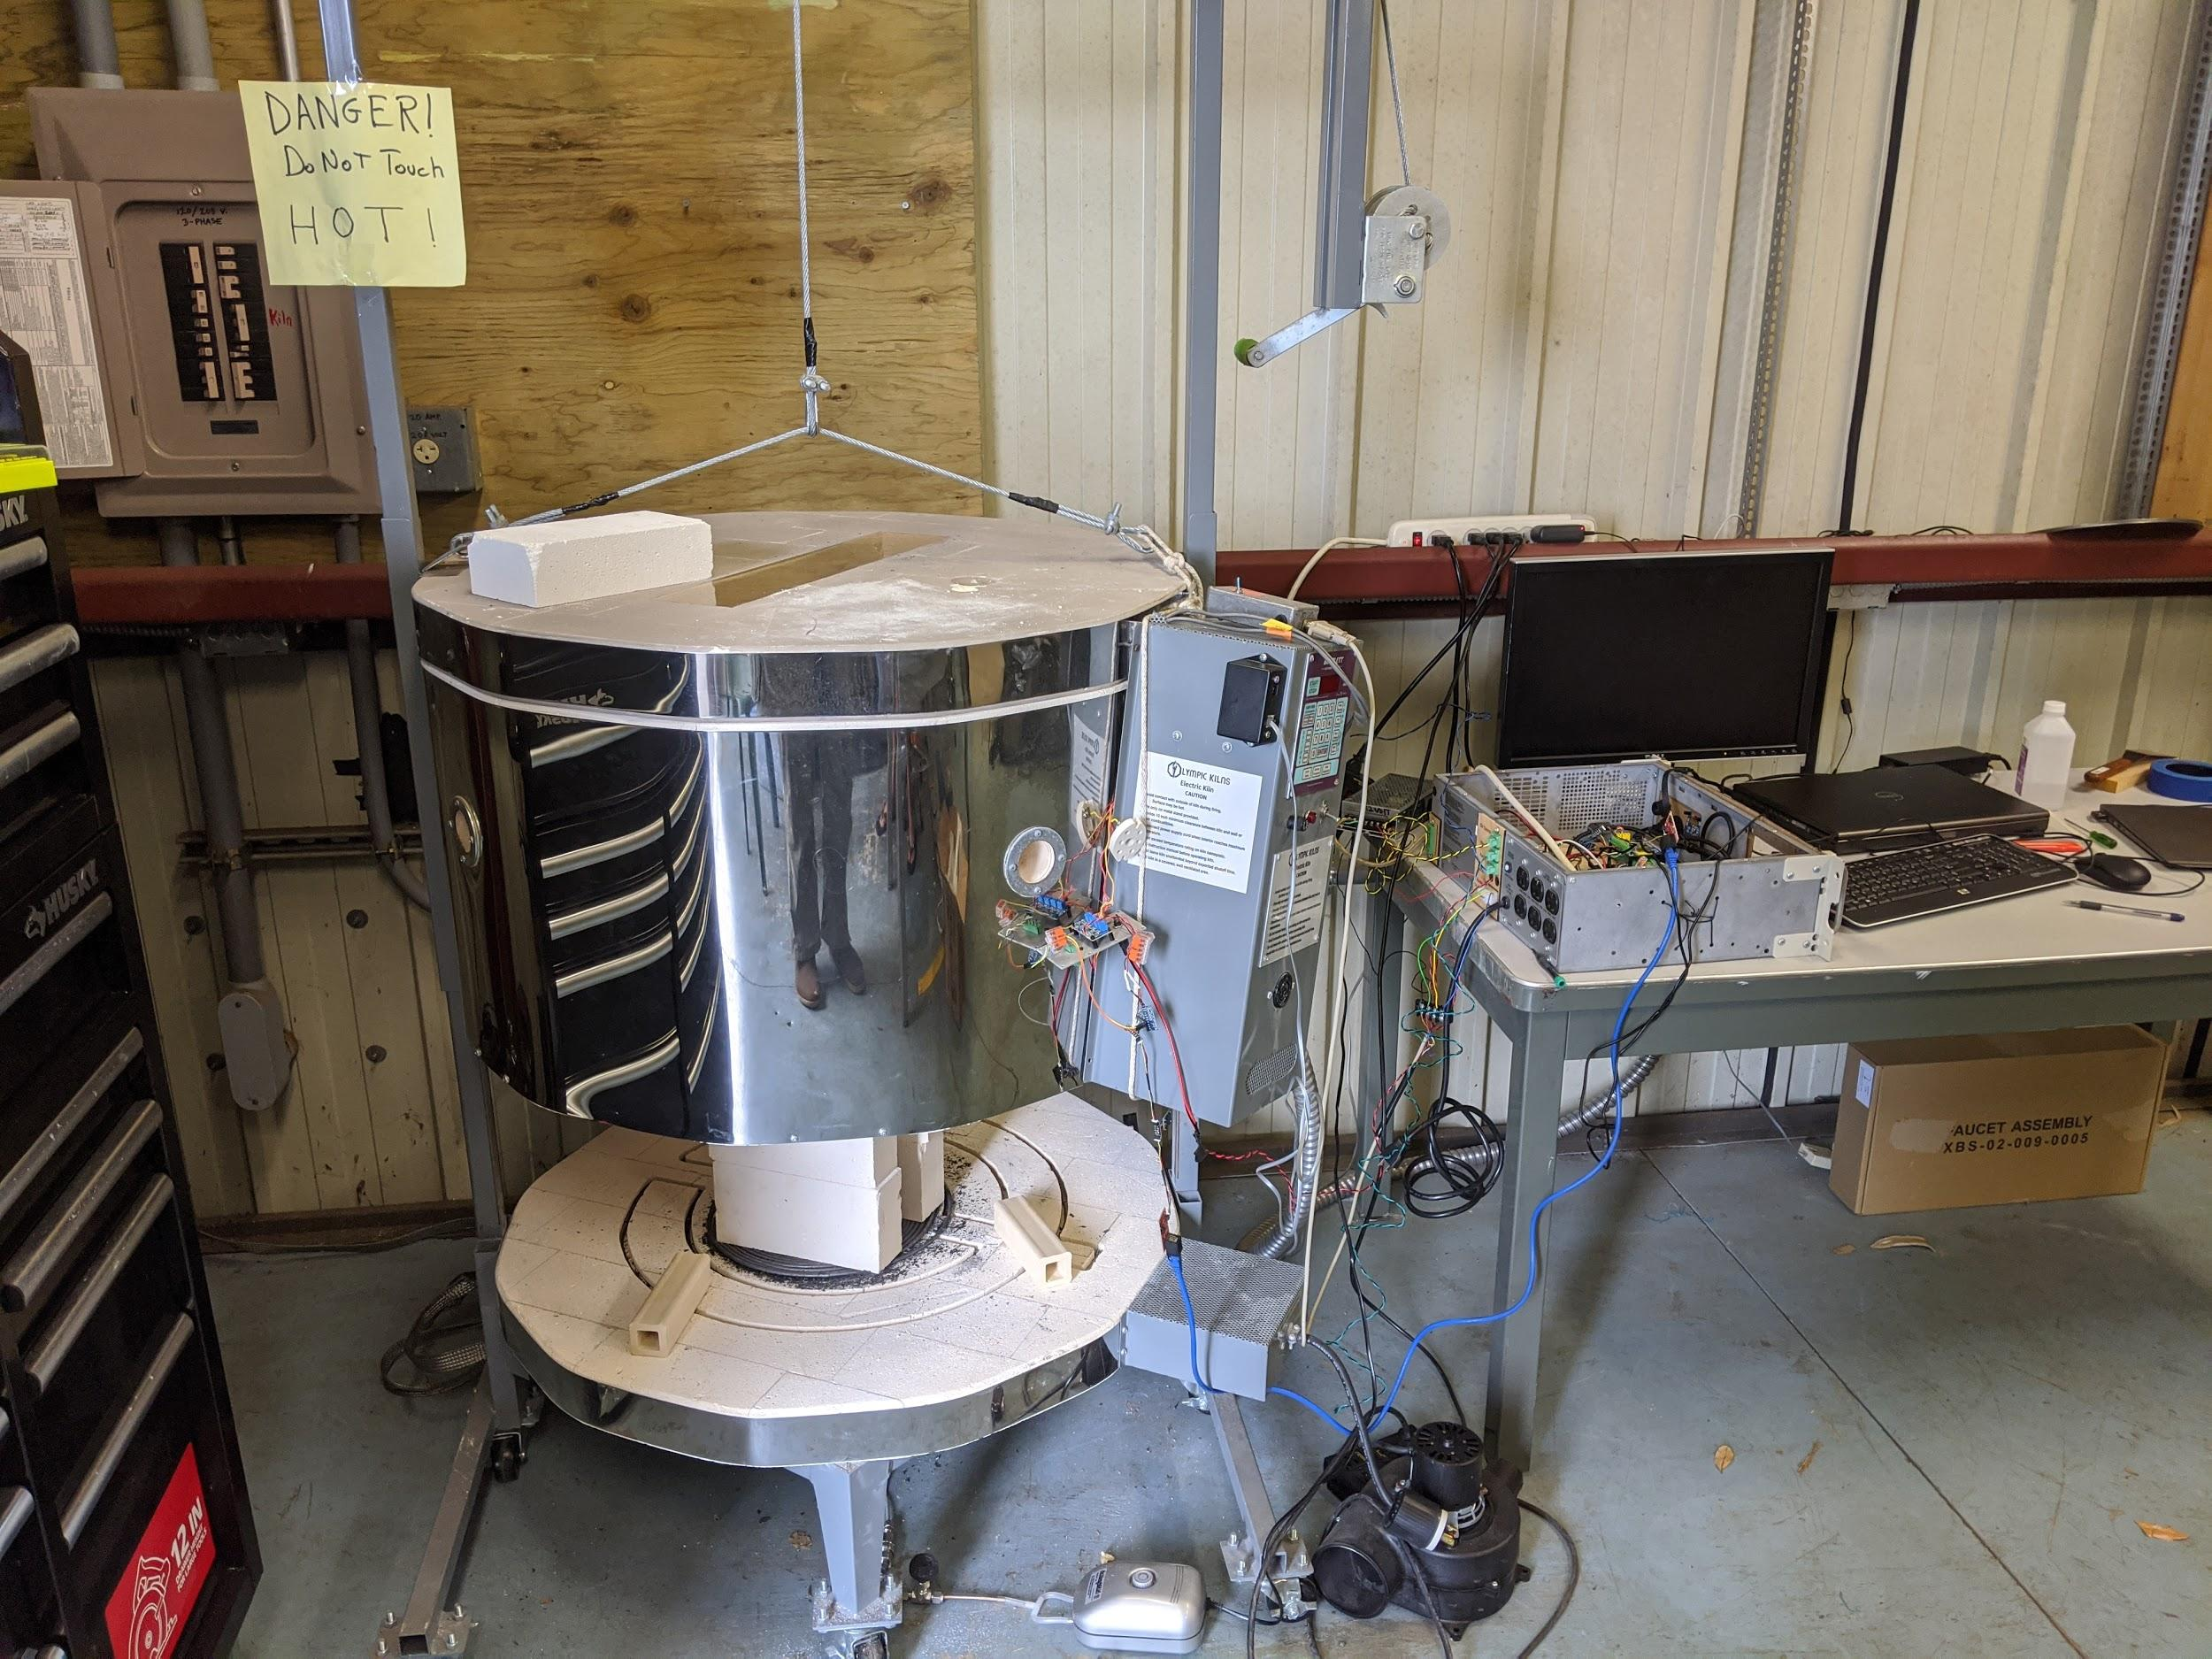

MODAC PoC physically consists of:

* Main Cabinet
* Heater Relay Switch Box
* Kiln Sensors
* External Power Strips

Photos of the June Installation are in a subfolder

* <https://drive.google.com/drive/folders/1vT3xqBGDffVKJEHyx7Fh8LhRGOuSqF-o?usp=sharing>
* a G.Presentation of these is in <https://docs.google.com/presentation/d/1wCMaHFE69drXNiUvN24ZZsVhTHZMaK_a-4Hsss59AhI/edit?usp=sharing>

## 2.1 Main Cabinet connections

* 3 x twisted pair to controlled power boxes (rear panel)
* keyboard/mouse to USB hub plugged to front panel
* HDMI plugged to front panel
* Cat5 cable for i2c to klin sensors (Enviro, 16bit AD+amp)
* 5v power to kiln sensors

## 2.2 Heater Relay Box

DB9 connector from metal box w/switch connects to 12v relays via ...

## 2.3 Kiln Sensors

A set of I2C sensors are located near the kiln. The number of sensors outgrew the original Thermocouple Amplifier box (TABox) provided by Morphoptic, and no replacement has been created.

The sensors connect to the Main Cabinet (MC) via a CAT5 cable with RJ45 connectors. The MC connection is inside the case, as it was added after panels had been created.

A twisted pair connects the TABox to the main cabinet with a 3mm (⅛”?) connector providing 5vdc power

Kiln sensor wiring is defined in the Design Documents

## 2.4 Power Strips

The system has several power strips, including one standard switched strip from the wall outlet to which the others connect. The Main Power

### 2.4.1 Main Power Strip:

* + - Always On plugs to monitor and MODAC case
    - Normally Off plug to 12vDC power
    - Strip control plug- two wire twisted pair from case

### 2.4.2 Fan Control Strips

Two Controlled Power Strips are used to control the Exhaust and Support Fans. These are similar to the Main Controlled Power Strip with twisted pair wires and connectors on the back side of Main Cabinet

# 3 Starting MODAC

The primary power to the kiln is a double breaker in the box in the corner. It must be on to run kiln heaters. It is not required for basic operation of MODAC otherwise.

## 3.1 MODAC Power On:

1. Turn on the primary (regular) power strip
2. Turn on Main Box/12v controlled power strip
3. Optional: If used, turn on two fan strips
4. Optional: Check batteries and turn on Leica Distance Sensor

MODAC System will boot to desktop on the external monitor

## 3.2 Power On Leica

If the Leica distance sensor is to be used, turn it on with central button. Insure it is pointed at target in the kiln. Target we have been using is high temp metal tape on the glass surface

## 3.3 Starting Applications

Two MODAC applications (Server and Client) are needed. Desktop icons are provided for the server (StartModac.sh) and the two client applications (startModacGui.sh, startKilnControl.sh ??) (note image needs update)

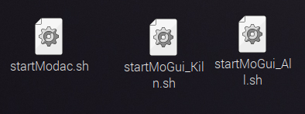

Double clicking on these icons will open a dialog asking if the item should be opened in an editor, terminal window, or headless. Generally use Execute in Terminal. This will open a Linux Terminal Window which will display all the Log (and print) messages from the application. The Terminal Windows are somewhat useful for watching what the applications are doing. The GUI Client applications will open their own windows. MODAC Applications could be run headless, and/or configured to start when the rPi is booted. That was not deemed useful at this time.

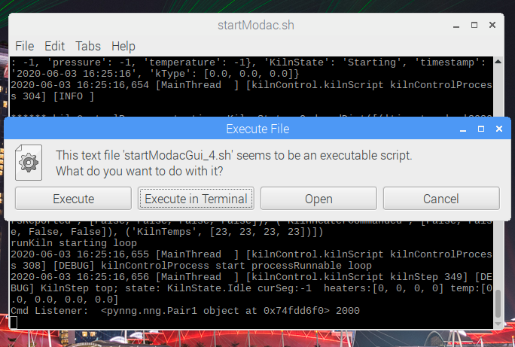

### 3.3.1 Start server first:

* + - power on Leica (if being used, also check/replace batteries)
    - double click MODAC_Server desktop icon
    - select execute or execute in terminal
    - Watch the flickering pixels for activity

### 3.3.2 Start Client

* Server could support multiple clients (GUI or headless, untested)
* Double Click MODAC_Kiln or MODAC_GUI icons on desktop
* select execute or execute in terminal
* UI clients will open own window. Log and other headless clients would have no desktop visibility other than the terminal window.

## 3.4 Kiln Power On:

The kiln is powered by a labeled double breaker in the wall panel. It is not required for editing of kiln scripts but (obviously) must be on for the kiln to run.

Additionally there is the old KISS GUI that runs on a PC laptop. It may be used to monitor kiln temperatures. Use of it is beyond scope of this document.

# 4 Graphical User Interface (Gnome, GTK)

The PoC MODAC GUI is built using Gnome, GTK, and MatPlotLib. It is a basic user interface for monitoring and control of MODAC. Two versions are currently supported although others were built during development.

All current GUIs share a “Tabbed Notebook” style window with Menu Bar at top, and a Status Bar at the bottom. It is a fairly simple GUI style and some aspects, such as gray/inactive buttons may be difficult to discern. The Tabs are various Panels created to monitor and control the Server. This allows a custom UI to be quickly assembled from pre-existing panels.

One common Tab Panel form used in the GUI is the “Data Table/Graph”. These panels have a scrolling data table at the top holding the last 100 values received for the data of interest. First column of the table is the date/time data was received. First row of the table are the field names. Below the Table is a MatPlotLib graph of the currently selected Data Column. Clicking on a column header selects the data to be displayed. Most recent values are at the top.

An Example Data Table/Graph

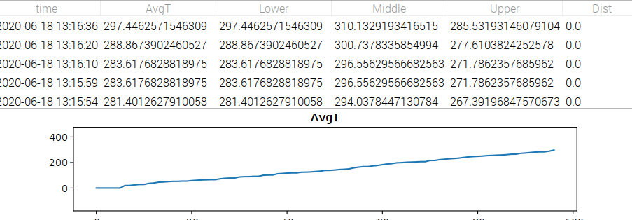

## 4.1 Menu Bar

(screen shots)

* + File: start CSV; stop CSV; exit
  + Help: displays outdated About Dialog

The GUI menu bar provides two primary items: File and Help. File provides means to start, stop and control timing of CSV File writing, and to exit the application. The help menu brings up a very out dated ABOUT dialog.

### 4.1.1 File Menu (CSV)

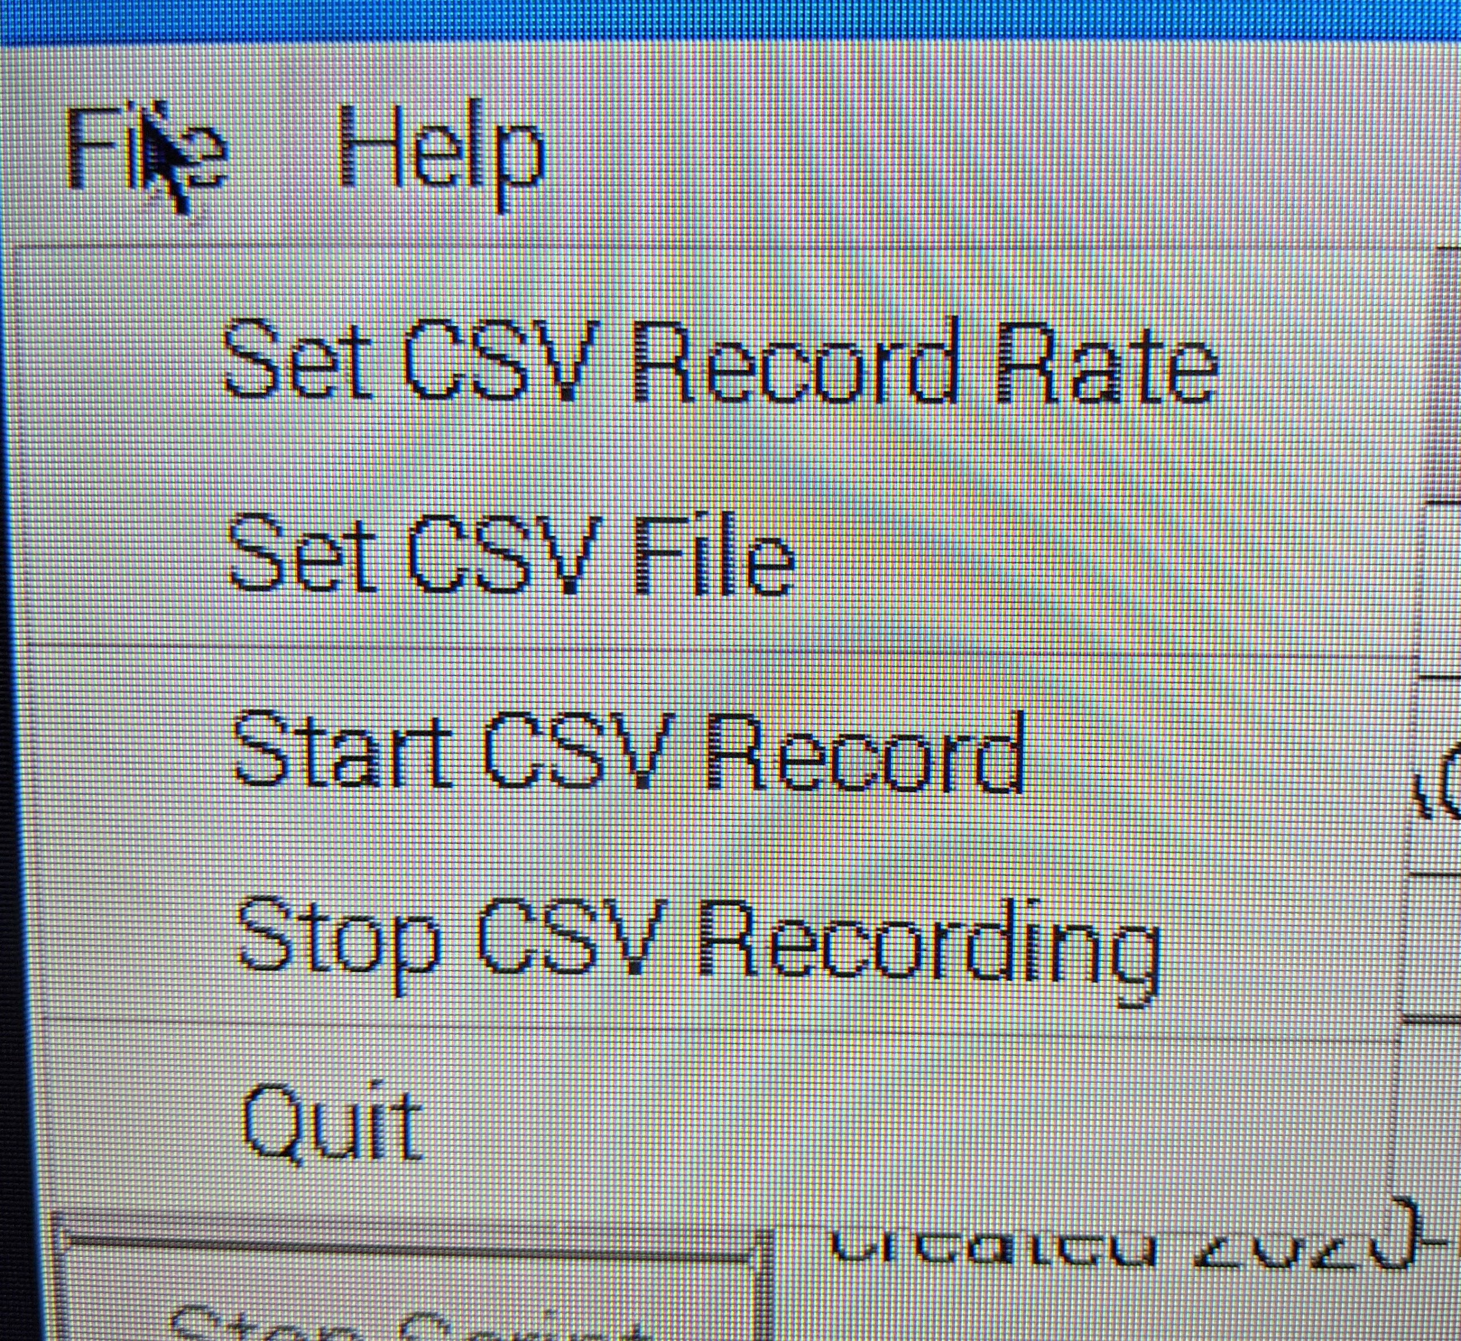

The GUI Client does not automatically save to data to CSV file, but the File menu bar item allow specifying the file name/location and write cycle time.

#### 4.1.1.1 Set CSV Record Rate

The “Set CSV Record Rate” item opens a dialog that lets you specify the number of seconds between recording of CSV rows. Note that the server has its own rate for sending data updates, and recording faster than this will only duplicate rows and slow the GUI tool. The kiln control scenario is very forgiving as real time control systems go. Data really doesnt change much so 60+ seconds is adequate.

Note the MODAC_Server application also records CSV files at its built in rate (1/min). The GUI function is thus duplication of effort, but if the GUI is on another machine, it may be more useful there without having to transfer the server file, etc.

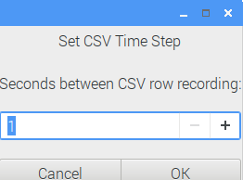

#### 4.1.1.2 Set CSV File

The “Set CSV File” item opens a dialog box to select the file that will be used to record the CSV data. You can change directory, name, etc. Default is to put the file in the “logs” folder.

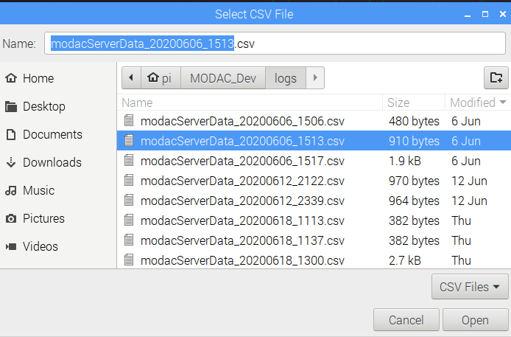

#### 4.1.1.3 Start CSV Record

The “Start CSV Record” menu item starts the recording of data to the specified (or default date/time) file. If recording is already in progress, it will ask if you wish to stop and use the new file.

#### 4.1.1.4 Stop CSV Recording

The “Stop CSV Recording” menu item stops recording csv rows.

#### 4.1.1.5 Quit

The “Quit” menu item does nothing. Quitting is for the weak.

Use the close X icon in upper right corner of window to end the application.

### 4.1.2 Help>About

The Help menu item has only one choice “About” which brings up a simple About Dialog. The Dialog has two buttons to display more data “Credits” and “License”

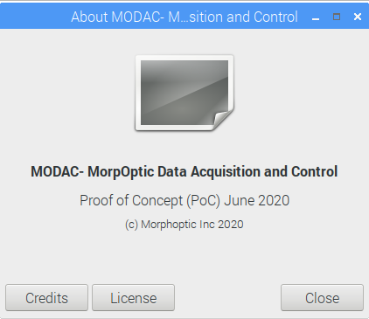

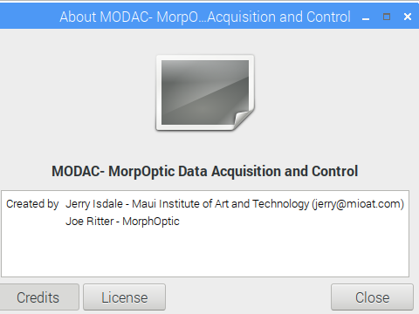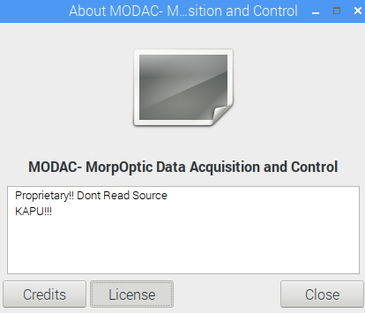

## 4.2 Status Bar

The status bar at the bottom of the GUI shows date/time of latest update message from MODAC Server. The default, before data messages are received, displays the message “Welcome to MODAC”. It may take a minute or two for the Client to connect with and receive a message from the MODAC Server.

## 4.3 MODAC_All:

MODAC_All is a test rig for all panels in tabbed notebook style.

*Insert screen shot and describe each tab (except Kiln)*

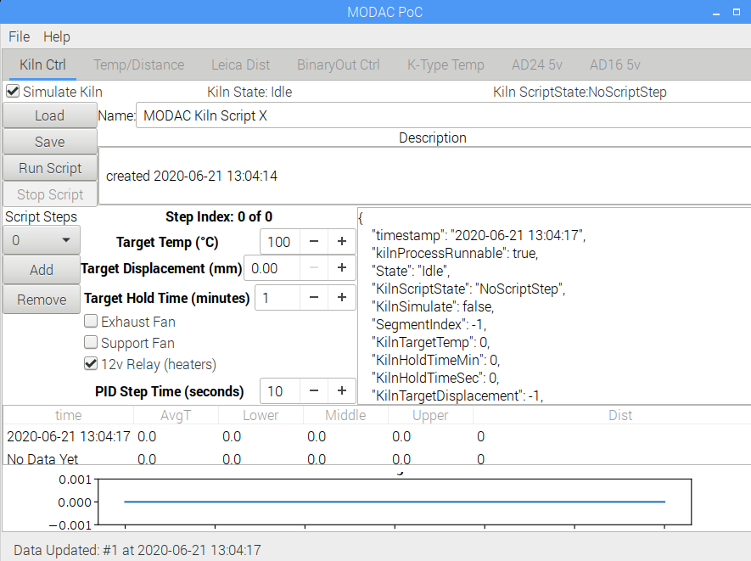

### 4.3.1 BinaryOutputs

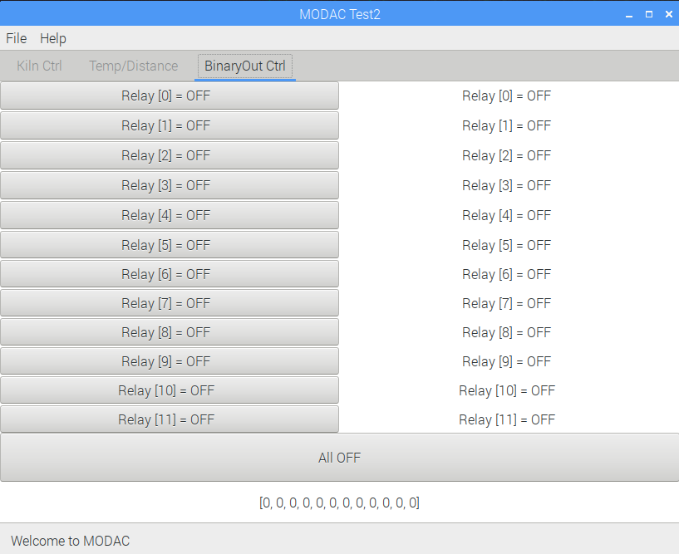

Binary Output Tab shows state of each Relay and allows turning them on and off. Left column holds a button for each relay. Right Column shows reported status of each relay. An All Off button is provided below; along with an array showing reported values.

Note there will be a delay between button press and updating reported value. This latency is determined by the loop cycles of the server and client applications. It can take 10-30 seconds for a change to be acknowledged.

### 4.3.2 AD16

Table + Graph for the four channels of AD16 device; Values are 0-5V

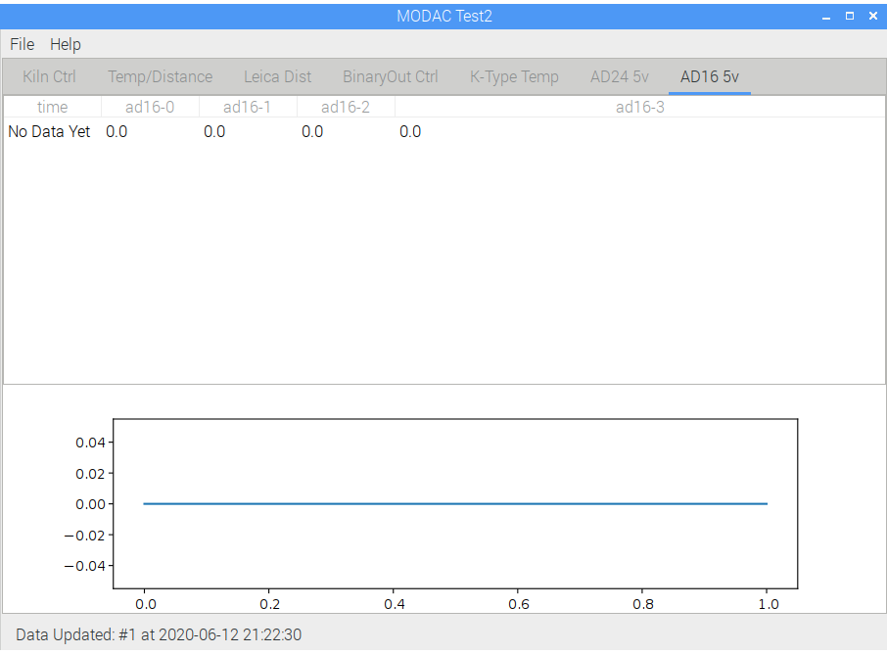

### 4.3.3 AD24

Table + Graph for the 8 channels of AD24 device; Values are 0-5V.

(is screen shot needed or waste of space?

### 4.3.4 Environment

Table + Graph for the BME environment sensor. Columns are

* Ambient Temperature (degC)
* Barometric Pressure (mbars?)
* Relative Humidity (units?)

### 4.3.5 Leica Tab

Table + Graph for the distance measured by the Leica Laser Distance Sensor

### 4.3.6 K-Type Tab

Table + Graph for the K-Type Thermocouples. 4 Columns are provided, one for each of 3 defined Thermocouples and the first being an average of others. Note that clicking on the average column will display a graph combining traces for other three values.

### 4.3.7 TempDist Tab

Table + Graph combining Leica and K-Type data (3 ktypes, average, distance)

## 4.4 MODAC_Kiln

The MODAC_Kiln application is a reduced set of tabs specific to kiln control, basically just Kiln Control and Binary Outputs.

### 4.4.1 BinaryOutputs

Displays and controls individual BinaryOutputs. See description above.

### 4.4.2 Kiln Control Tab

The Kiln control tab provides rudimentary editing and monitoring of Kiln Scripts. You can load/save, run and stop a script, change parameters and monitor execution. The top are provides general info on the Kiln and script. Middle area provides script step info. Bottom area shows K-Type and Distance data table+graph, similar to other table/graph panels.

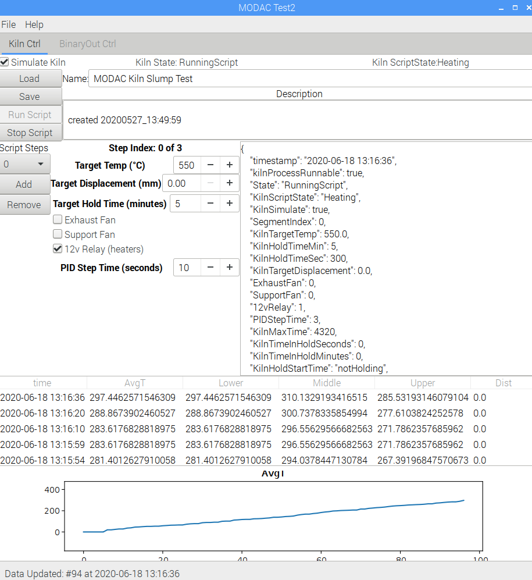

#### 4.4.2.1 Kiln Control Top Area

The top area of the Kiln Control Panel has a status bar at top, 4 buttons on left side, and two data entry areas on right side.

##### 4.4.2.1.1 Top Area Status Bar

* Simulate Kiln Check box: if checked script will be run in Simulate Mode. Simulation is run in server using simulated K-Type sensors. No relays will trip, and AD is data is not used.
* Kiln State: gives current state of Kiln Control: Idle, RunningScript are normal
* Kiln ScriptState: gives state of kiln script: NoScriptStep, Heating, Holding are normal

##### 4.4.2.1.2 Top Area Buttons

Top area has four buttons on left side.

* Load: opens dialog to load a kiln script (JSON) file. An error dialog will show if there is an error in the script. Details of error are in the log file
* Save: opens dialog to save current kiln script as JSON file
* Run Script: sends current script to MODAC Server to run. Note it may take 10-30sec for response to show changes in GUI - notably the KilnState and ScriptState will change. Button is inactive (gray) while script is running.
* Stop Script: sends Stop Script message to MODAC Server. Note it may take 10-30 seconds for response.

##### 4.4.2.1.3 Top Area Data Entry

The Top Data Entry area has two fields:

* Name: a free form text area for internally naming the script. Default is date/dime.
* Description: longer free form text area for describing the scrpi. Default is create date/time

#### 4.4.2.2 Kiln Control Script Step Area

The ScriptStep Area has 3 parts. Buttons on left, center data entry/display, and scrolling status on right.

##### 4.4.2.2.1 Script Buttons

Three Buttons on the left control step displayed, adding/removing steps

* Script Step select: pull down to display step by number
* Add: adds a step to the end of script
* Remove: removes the current step

(note: PoC does not provide more advanced editing of script, including moving steps, etc)

##### 4.4.2.2.2 Script Step Data Entry/Display

The Script Step Data area has fields to show and modify the current step. Note modification should only be done BEFORE running script. Changes made after Start will not be sent to Server. During script running, these values will be updated when status messages are received from Server.

* Step Index N of M: shows which step is being edited or running. Note steps are numbered from 0, while the total starts at 1. Thus a single step script (default) is 0 of 1.
* Target Temp (degC): entry/display of target temperature for this step (Default 100C). Should take direct entry as well as 10DegC -+ steps. ScriptState will be “Heating” until thermocouple average reaches this value. (note code has default to only use bottom K0 thermocouple value.) Upon reaching this temperature, state will change to “Holding” until either Hold Time, Target Displacement or max time is reached (max time is a constant in code that is generally several hours)
* Target Displacement (mm): entry/display of target displacement from 0. If 0 (default), the script will ignore this. If non-zero, “Holding” will continue until the distance reaches this distance, or time constraints are met.
* Target Hold Time (minutes): time to hold target temperature (aka soak time)
* Exhaust Fan (on/off): Kiln Exhaust Fan relay is on or off for duration of step
* Support Fan (on/off): Kiln Support Fan relay is on or off for duration of step
* 12v Relay (heater power, on/off): Relay controlling 12v power to kiln heater relays is on/off for duration. NOTE: this must be ON (checked) for kiln to heat.
* PID Step Time (seconds): time between each PID (temperature check). 10sec is default and should be adequate. Smaller values may make PID controller unsteady (given slow response time of kiln). Longer values are possible but should not exceed 60seconds.

##### 4.4.2.2.3 Script Status Display

The right hand scroll window shows the most recent JSON Script Status message received from the MODAC Server. These are used to monitor parameters of the script. (Details? Beyond simple documentation and subject to change)

#### 4.4.2.3 Kiln Control Bottom Data/Graph Area

At the bottom of Kiln Control Panel is an instance of the Temp/Distance Data Panel. It shows the K-Type and Distance values. As with other Data/Graph panels, clicking on a column header displays that parameter in the graph.

## 4.5 Kiln Usage

How to Run a Slump

The primary power to the kiln is a double breaker in the box in the corner. It must be on to run kiln heaters.

1. Power on MODAC
2. Start MODAC_server
3. Start MODAC_client
4. Load or define script (Kiln Control Panel)
5. Check to be sure Kiln and Fan Power is on
6. Optionally start KISS monitoring on old laptop
7. Start Client CSV recording if desired
8. Select “Run Script” on the Kiln Control Panel
9. Watch the updates: date at bottom, table/graph, script status box

Note: Screen may blank if no user interaction within N minutes. Moving the mouse *should* bring the display back, however, sometimes the rPi seems to stop listening to the USB devices.

# 5 Graphical User Interface (TK)